Week 4

Marketing Information and Research

Learning Objectives
- Explain the importance of information in improving marketing decisions.
- Define the marketing information sources.
- Understand how to conduct a marketing research.

1. Importance of marketing information
Marketing is a process of building customer relationships by creating value for the customers and capturing value in return. To create customer value, companies need to understand customers’ needs and the current situations surrounding customers. Such understandings can be obtained by gathering and analyzing relevant data to discover useful marketing information that can be used to make better decision-making (i.e. insights). Having useful, reliable, and accurate information is vital to effective decision-making as it can help a marketer in understanding changes in the marketing environment, and thus reducing uncertainties.

The instructor begins the session with the discussion question to introduce marketing information
1. Have you provided your personal information to any business? What information? through which channels?
2. Has any business collected information about you beyond the channel in Q1? How?

2. Sources of Marketing Information
Marketers can obtain useful information from three main sources as follows
2.1 Internal Databases
The collections of consumer and marketing information that are obtained by using data sources within the company network. For instance, sales transactions, and records of online activities. It is easy to access and considered cheaper than other information sources. However, it could be misleading for making important decisions.
2.2 Marketing Intelligence
It is a collection and analysis of publicly available information about the consumers, competitors, and marketing environment. Marketing Intelligence enables marketers to quickly respond to problems and opportunities. For example, consumer’s mentions of the brands on social media which allow marketers to understand the brand presence in the market.
2.3 Marketing Research
Marketing research is the process of collecting, analysing, and reporting marketing information that can be used to answer questions or solve marketing problems. It also helps reduce uncertainty in order to improve decision-making towards a marketing plan. A research can help marketers gain insights into customer’s behaviour, measure the effectiveness of marketing mix, and assess market potential. It is usually done at a specific time with a specific purpose and set of questions. A company can do it by itself, or by outsourcing to research firms. There are various scopes of marketing research. For example, a product research which focuses on the individual product which allow the company to modify it to suit the consumer’s needs.

Google Trend analysis
* students are asked to work in a group and learn how to use google trend to analyze the brand
1. Choose 1 product from the industries that are quite competitive and have many strong competitors, and explore 3 brands
2. Use google trend to find the relative popularity, try change the time period (e.g. before vs. after Covid19 pandemic), geographical area, categories, web/youtube/image search, and capture the figures and summarize interesting findings and come up with recommendations for each analysis
3. Use google trend to find interesting related topics/queries, summarize interesting findings

3. Marketing Research Process
The market research process is a systematic methodology for making business decisions. There are six steps towards doing a market research as shown in the figure down below.

3.1 Problem Formulation
The first step for any marketing research activity is to clearly identify and define the problem you are trying to solve. You start by stating the marketing or business problem you need to address and for which you need additional information to figure out a solution. Next, articulate the objectives for the research: What do you want to understand by the time the research project is completed? What specific information, guidance, or recommendations need to come out of the research in order to make it a worthwhile investment of the organization’s time and money?
There are three main types of research objectives
- Exploratory Research
It is useful when you are initially investigating a problem but you have not defined it well enough to do an in-depth study of it. The objective of exploratory research is to gather preliminary information that will help define the problem and suggest hypotheses which help establish priorities for further research. The methods that can be used are as follows; secondary data analysis, qualitative research, and pilot surveys
- Descriptive Research
The objective of descriptive research is to describe things by conclusive results; such as the market potential for a product or the demographics and attitudes of consumers who buy the product. A descriptive research design involves gathering hard numbers and having structured design, often through surveys, to describe or measure a phenomenon so as to answer the questions of who, what, where, when, and how.
Examples of methods that can be used are “secondary data analysis, surveys, and observational data”.
- Causal Research
Causal research aims to test hypotheses about cause-and-effect relationship in marketing by having researchers manipulate variable in order to examine the cause and effect relationships. It is usually done after the exploratory research and conducted in a laboratory or closed environment.
3.2 Research Design
It is the framework for conducting the marketing research project; detailing the procedures that are necessary for obtaining the information needed to structure or solve marketing research problems, The research could be done by using internal resources or externally by hiring outside firms to carry out the research.
1) Data:
There are two types of data sources that the firm can use; secondary and primary data.
Secondary data uses the existing research for new purposes. It is usually cheaper and takes less time for researcher to analyse. However, it can be irrelevant and obsolete for the current research. They could be found both internally and externally of a company. An example of internal secondary data is the sales record of the company. For the external secondary data, researchers can find it from many places, such as syndicated research firms, or government.
Primary data is the information that is collected for the first time specifically for a specific research question. The information would have more details and answer the specific question researchers have in mind. However, it is usually more complicated, costs more, and can take a long time to collect the data. An example of a way that researchers can obtain the primary data by asking customers about their attitudes and reported behaviours. However, some participants may not be able or willing to answer some questions. Researchers can also combine the survey with observation which can help obtain the real behaviors of customers. In addition, there are certain data such as prefered price or store ambience that researchers may not be able to ask from customers directly or observe people’s behaviors. Thus, another method to obtain the data is to conduct the experiment to test what if type of questions (If a firm changes a product’s price, design, place, advertising), what will happen to an outcome (e.g. sales, customer satisfaction). More details about these methods are described at the data collection section.

2) Research methods
To understand different types of methods that researchers can use to collect the data, it is important to understand the differences between qualitative and quantitative methods.
Qualitative methods are ways of collecting data that yield results such as words or pictures. Qualitative research focuses more on understanding reasons behind human behaviours to answer why and how consumers do what they do. It is usually done by interviewing, or conducting a focus group. This type of research is usually unstructured and non-statistical.
Quantitative methods, on the other hand, result in data that can be represented by and condensed into numbers. Quantitative research focuses on generalising the results from the sample and apply them to the population. While qualitative methods aim to gain an in-depth understanding of a relatively small number of cases, quantitative methods offer less depth but more breadth as they focus on a much larger number of cases. It uses statistical and mathematics method in order to conclude the results for deciding the final course of action. There are many ways to conduct quantitative research, such as survey, observation, and experiment.
3) Sampling
Sample is a selected group of population that has all the important characteristics of the population from which it is drawn to represent the population as a whole.
There are three sampling design decisions that should be made before deciding which sampling method should you take.
- Sampling Unit - Considering of who should be studied
- Sample Size - How many people should be included in the research
- Sampling Procedure - How should the people in the sample be chosen

There are several sampling procedures that marketers could choose from which are as follows
Sampling methods | Description | Sampling techniques
Probability sampling | Samples are selected based on the randomization so everyone has the chance of being selected  Suit quantitative research method | Simple random sampling: population members are randomly picked  Systematic random sampling: a random sample in which each piece of data is chosen at a fixed interval.  Stratified random sampling: The population is divided into mutually exclusive groups (e.g. gender, occupation, education), and random samples are drawn from each group  Cluster random sampling: The population is divided into mutually exclusive geographic cluster and samples are drawn from each cluster.
Non-probability sampling | Samples are selected based on the personal judgment/convenience  Suit qualitative research method | Convenience Sampling: samples are chosen based on their relative ease of access.  Judgmental Sampling: select samples who are good prospects for accurate information  Quota Sampling: People are selected based on some categories (e.g. sex, age, or race). The number of samples in each category is in proportion to a population of interest.  Snowball Sampling: Find few people who are relevant to the research subject and ask them to find suggest the next participants.

3.3 Data Collection
As mentioned before, marketers can choose between qualitative or quantitative approach when collecting data. The table below shows the data collection methods that they can select, alongside with benefits and challenges for each method.

- Qualitative approach

Data collection methods | Description | Advantages | Disadvantages
Focus group interview | Interview 6-10 people that who have homogeneous characteristics  Conducted by a moderator | Useful to obtain detailed information  Opportunity to seek clarification | Expensive  Difficult to conclude the findings from small group of people  Group thinking - Participants follow other’s opinion.
In-depth Interview | Detailed one-on-one Q&A session (30-60 minutes) | Rich depth of information  Uncover hidden issues  Suitable for finding personal opinions (such as beliefs & motivations) | Required skilled interviewer  Expensive and time-consuming
Ethnography | Trying to understand how people live by observing and interacting with participants in their natural settings | Free from distortions and inaccuracy  Uncover problems that consumers may not know | Time consuming and costly  Motivations and attitudes cannot be observed

- Quantitative approach

Data collection methods | Description | Advantages | Disadvantages
Observation | Involve recording the behavioral patterns of people, objects, and events in a systematic way | Free from distortions and inaccuracy  ,Good for explaining meaning and context | Can be too subjective  , Time consuming
Experiment | Procedure in which the experimenter select matched groups, give them different treatment, control unrelated factors, and check the differences in each group’s responses towards the treatment to test the effect of treatment on customer responses | Help determine cause and effect of a study | Can be expensive and have difficult procedures
Survey | Gathering information from a group of people and generalising the results to a larger population. | Flexible, can obtain various kinds of information  Can be conducted by various methods (e.g. phones, face-to-face, mail, online) | Consumers can give  inaccurate answers  Respondents may not remember about what they do and why  Respondents give inaccurate answers

There are many methods that marketers can use to conduct a survey, which are shown in the tables down below.

- Survey contact methods
Survey methods | Description | Advantages | Disadvantages
Telephone survey | Conduct a survey via telephone. Suitable for short and easy survey. | Quick and inexpensive  Gives a better coverage in terms of sample spread | Many people refuse to take part or are reluctant to give personal information over the phone
Personal survey | Conduct a face-to-face survey. | Can obtain detailed information and ask follow-up questions. | Higher cost than other methods
Mail survey | Respondents complete questionnaires on paper and return them via the mail | Cost-effective and provides anonymity | Lower response rate, time consuming (long follow-up time),  Poor data quality
Online survey | Respondents complete questionnaires on the selected website. | Fast survey process that gain big sample sizes  Overcome geographic boundaries | Can have low-response rate  Skewed samples and inconsistencies
3.4 Data Analysis
After the marketers collected the data, they need to clean, transform, and analyze the data with the goal of discovering customer and market insights which will improve their marketing decisions.
- Qualitative Data Analysis.
  - Step 1 : Get to know your data. In order to understand the findings, you have to first transcribe the data and read it. Highlight the important findings as you read, and write the code/keyword.
  - Step 2 : Categorise data to create meaning. In order for qualitative data to be analysable, it must first be grouped into the meaningful categories or themes that you observed when you read and code.
  - Step 3 : Connection within & between categories. As you organize the data into categories, you will discover the relationship within and between categories such as in terms of similarity/difference, cause/effect, or sequence. Such connections are important to look for, because they can help explain why something occurs.
  - Step 4 : Interpretation. Read between the lines. Think about what you have learned. Once you finish listing the list, develop an outline for presenting your results to other people or for writing a final report.
- Quantitative Data Analysis
  - Step 1: Get a big picture of data. A simple data analysis technique using frequency distribution (histogram) allows understand the overview of the data, to see how frequently the specific values are observed, and what their percentages are for the same variable.
  - Step 2: Descriptive Statistics (mean, median) are used to describe the basic features of the data in a study. They provide simple summaries about the sample and the measures.
  - Step 3: Cross-tabulation and correlation can be used to analyze the relationship between two variables. Linear Regression can be used to test the relationship between the response and predictor variables.
Data interpretation goes further to explain what the research findings mean and translate them into recommendations for the marketing team. For example, What are the market segments you have identified, and which ones should you target? What are the primary reasons your customers choose your competitor’s product over yours, and what does this mean for future improvements to your product?

3.5 Report
Once the information has been processed and analysed, marketers will formulate conclusions and implications into marketing reports. There are many ways that marketers can make a report, such as using graphs, charts, slides, and so on. By having reports that are giving valuable insights, they can be useful in developing and improving the marketing plan of the company. It is worth mentioning that many marketing research projects are never translated into management action. Sometimes this is because the report is too technical and difficult to understand. In other cases, the research conclusions fail to provide useful insights or solutions to the problem, or the report writer fails to offer specific suggestions for translating the research findings into management strategy. These pitfalls can be avoided by paying due attention to the research objectives throughout the project and allocating sufficient time and resources to do a good job interpreting research results for those who will need to act on them.

Research plan exercise
*students are asked to analyze the scenario in the appendixes (e.g. Honda, Burger King, Pepsi), and complete the research plan asking them about research objectives, secondary and primary data needed, research methods suitable to the scenario, sampling procedure, sampled questions and observation guideline

Discussion Questions
1. Discuss the sources of internal data and the advantages and disadvantages associated with this data. (AACSB: Communication)
2. Explain the role of secondary data in gaining customer insights. Where do marketers obtain secondary data, and what are the potential problems in using such data? (AACSB: Communication)
3. Perform an Internet search on “social media monitoring” to find companies that specialize in monitoring social media. Discuss two of these companies. Then find two more sites that allow free monitoring and describe how marketers can use these to monitor their brands. Write a brief report on your findings. (AACSB: Communication; Use of IT; Reflective Thinking)

References
Fripp, G. (2017). The Practical Marketing Workbook, 2nd, Sydney, Australia.
Kotler, P. T. and Armstrong, G. (2013). Principles of Marketing, 15th, Pearson.

Appendixes

Marketing Research Terms
In this straightforward activity, your task is to match the marketing research term to its
definition/best description below?
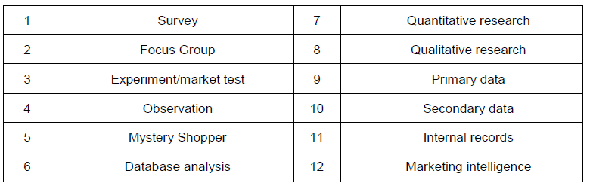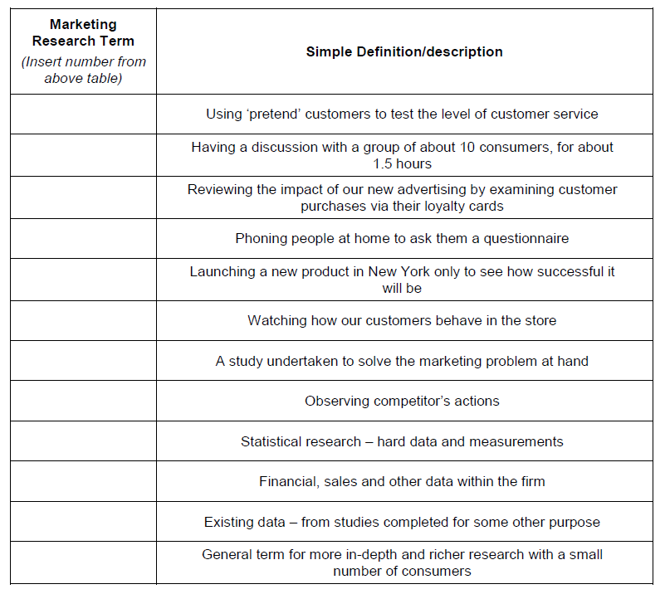

Research Plan
Instruction: choose one of the following scenarios, and complete the following table

- Consumers are more and more health conscious and many are interested in riding a bike. Honda is considering whether they should produce its signature bike.
- Pepsi co. is thinking about introducing a new flavor of Pepsi. The company would like to know if this new flavor will be accepted and purchased by its target consumers.
- Burger King would like to renovate its store environment to make it more appealing to younger group of consumers (13-18 years old). Currently, the burger chain has no idea about this target group.
- As there are many websites/fan pages competing over consumer attention, an online magazine would like to increase the number of viewers. They would like to know more about customers’ lifestyle and reading behaviors so they can improve their online contents.
- One of a maor consumer product company is aiming to target a metrosexual male. The company would like to know their lifestyle, their opinions and attitudes, as well as their consumption behavior.
- TAT would like to know whether they should create Thai movies to promote Thailand tourism. They want to assess the impact of movies on tourism.
- Zara would like to test whether color can influence their sales. They consider yellow, red, and green in a store design and would like to learn if there is a difference in price perception and purchase intention between stores using different colors as background
- There is a great number of individual sellers selling whitening products on the social media. Although it is quite obvious that products that are sold online are not reliable, there are still many buyers. Researchers seek to know characteristics of buyers and why they still buy those products.

Objective
Research type
Secondary data (specify data needed and source)
Primary data
(specify data needed and research methods)
Samples
(who, where to find, how to recruit)
Key questions to be asked in the survey/interview

What you will observe (in person, at store, or via social media)

Research plan for project

BRAND:_______________________ GROUP:___________ SECTION: ____________

Issue | Description
Target customer
Product offered and Signature product
Competitors
Brand Value
User Personality
Strength
Weakness
Opportunities
Threats
Main marketing problems
Research objectives
Data types and sources
Research approach/ method

Sampling decisions (how)
Sample questions

